Technical Design Document

Project name: **Loan Application**

Name: *Prajakta Shirsath*

**Introduction:**

Loan Application is created to meet the needs of online banking system, The architecture implemented is Spring Boot .

**Functional Requirements:**

The functional requirements of the project are:

* Login/register
* Apply for loan
* Check balance
* Calculate EMI
* Pay EMI
* Deposit
* Foreclose
* Print Transactions

**Class diagram**

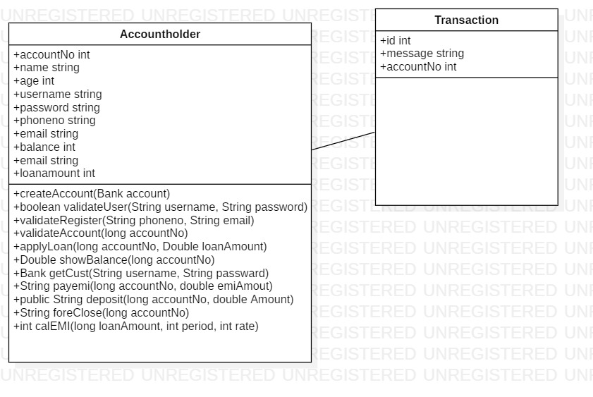

**Sequence Diagrams**

**Login –**

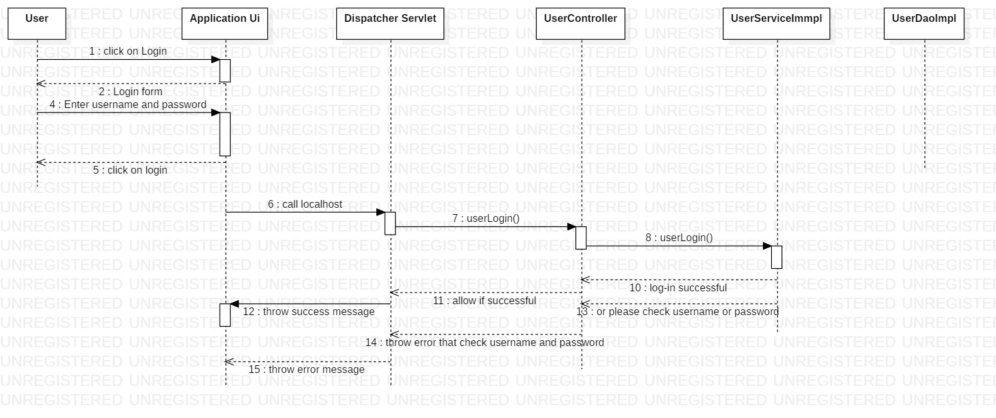

**Registration of new User –**

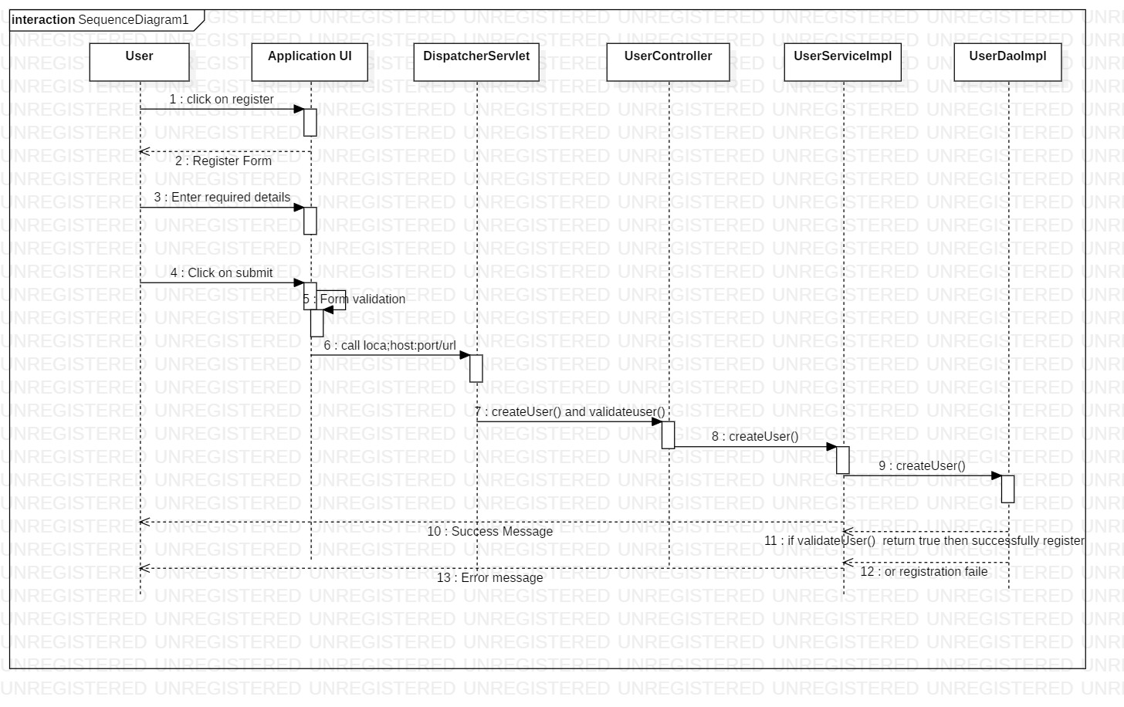

**Activity Diagrams**

**Login:**

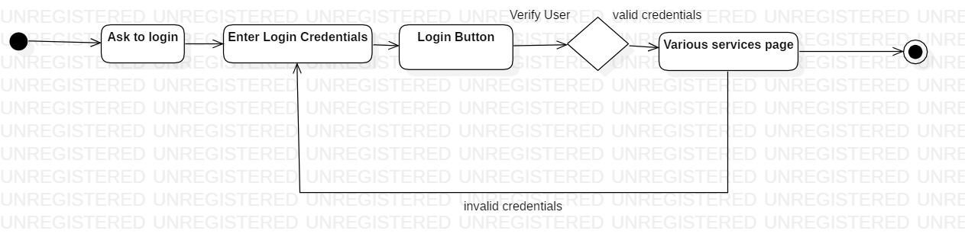

**Registration:**

